**Online Quiz Application**

As a developer, you are assigned to a project to develop a quiz application where user can select the option for quiz and start the quiz. Once the quiz submitted user can see the results which is updated.

Questions you can load from JSON file.

Manage user data using State management (Array)

**You must use the following:**

**Implement the application using Angular + NgRx**

**Output refrences:**

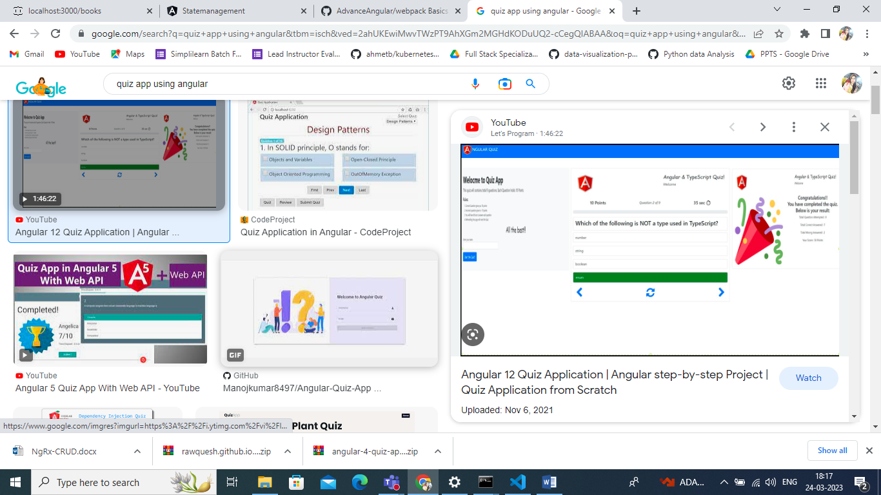

After Submission

